

ISSN 2321 3361 © 2021 IJESC

Research Article Volume 11 Issue No.04

Virtual Travel Guide (E-Bot) – A Detailed Information for Our Indian Monuments
S. T. Santhanalakshmi¹, Ruth Mariya. S², Shaini A. Ravi³
Associate Professor¹, Student^{2, 3, 4}
Department of Computer Science Engineering

Panimalar Engineering College, Chennai, Tamilnadu, India

Abstract:

Access to relevant and accurate information is at the heart of tourism, more so in this era of the Internet information overload has become a prevalent phenomenon and as such a serious issue for those seeking for appropriate information. Furthermore, various researches have been carried out on how to make information on tourism website more effective. Intelligent tourism management system tries to bridge the gap by nothing what a tourist perceives as relevant, in terms of content pertaining to tourism products in tourism websites. This study focuses mainly on content because it is seen as the key factor associated with an effective website. Hence, the aim of this research entails the design and implementation of an intelligent platform that will assist tourists in gaining access to information on tourist locations in India. Upon completion, the system was able to provide information by fetching information from the web pertaining to the subject of interest to assist tourists in decision making process. It was also able to act intelligently by using hybrid recommendation technique to recommend tourist locations based on their preference.

Keywords: Tourism; Intelligent; Tourism Management; System.

I. INTRODUCTION

Over the years, tourism has continued to gain massive interest at a global scale. It is a major foreign exchange earner for a good number of advanced and emerging economies. It is also true that information explosion makes it cumbersome times to access relevant information to enhance decision making. This has given rise to the emergence of intelligent systems or mechanisms that facilitate quick access to relevant content found in the Internet. For developing countries like India, tourism is one of the untapped but potentially big income generator. There are about 75 tourist destinations that spread across the 29 states of the federal republic of India. Whereas some exist naturally, others are manmade. In this era that has witnessed rapid advances in information technology, information overload has become a serious problem to those seeking for information online. Recently, intelligent search mechanisms have been deployed on the web that shows that the problem of information overload can be partially eliminated by providing a platform with more intelligence to assist tourists in the search for relevant information.

Google.com is an example of an intelligent search engine that helps users with information and another class of intelligent system that has proven relevant in addressing the problem of information overload are recommender systems . In the aspect of tourism, Internet and web technologies have made more readily available information on tourist locations. Also a chatbot is an added feature where user related queries are identified and solved. The goal of this research is to design and implement intelligent platform that will aid tourists in India to have access to information on tourist locations thus help fasten their decision making process.

II. RELATED WORKS

So many researches have been carried out relating to intelligent tourism management systems with significant impact in the tourism industry around the globe.

Some of the research works carried out by researchers as related to intelligent tourism management system are discussed in the succeeding sub-sections.

2.1. The Application of Intelligent Tourism Mobile Client Based On Ontology

This paper proposed the application of ontology theory in the research of intelligent tourism mobile application client. The adopted method (ontology) helps to structure the kind of information given to tourists thus eliminating room for information ambiguity. The strength of this research work is based on the fact that it makes use of an organic combination of the major elements that are closely linked to tourism, and infiltrates them it into every aspect of tourism which produces an effective, intelligent and efficient tourism information system. However, its weakness is based on the fact that it is mobile-based and hence accessibility is limited to mobile device users.

2.2.Destination Information Management System for Tourists

The system was designed for tourists taking Nigeria’s tourism into consideration. This was to provide tourists with intelligent interaction based on virtual community concept of tourism and locals that have common interest theme. The system aims at bridging the gap; which is the lack of interaction that exists between tourists and locals at a particular destination. The advantages of the system is it is user-friendly, interactive,

IJESC, April 2021 27974 http:// ijesc.org/

supports security and compatible to various web servers but the system lacks intelligence in providing information to tourists, thus reducing the stress at which tourists seek for information on the system .

III. PROPOSED SYSTEM

In recent years we have came across many chat bots which are purely based on AI which provide an Output which is majorly less precise than what a user thinks.

(To make the User get the most Comfortable and Friendly Experience). We use a new technique for making the user feel that he is not chatting with a computer software rather the system will pretend itself to be a human. (By providing a better UI than Previous).

The user interaction with the system will be improved in a way that he will often prefer a ChatBot rather than choosing a customer care executive.

MODULE.1.TOURIST PLACE INFORMATION

In this module the information about the tourist places are given i.e., the history of the places or the information regarding the places. Also there is a chat bot to clear the users doubt regarding the places. For example to look for the nearby hotel, the user can chat with the chatBot to know the details. Thus providing the entire detail regarding the spot including the surrounding details. The advantages of the system is it is user-friendly, interactive, supports security and compatible to various web servers but the system provides information to tourists, thus reducing the stress at which tourists seek for information on the system
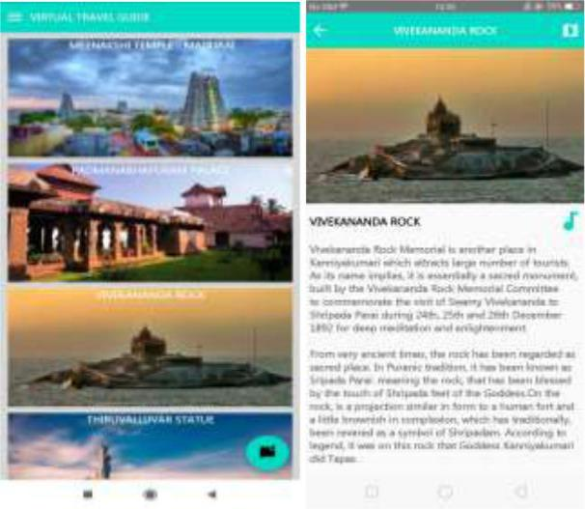

MODULE 2. AUDIO

This provides the voice output where the details of the tourist spot is voiced out. With audio autoplay, you can focus on your surroundings. Put in your headphones, tap on Audio button, and let audio guide you. Later multiple language audio output feature can also be added to this application.

MODULE 3. LOCATION (MAP)
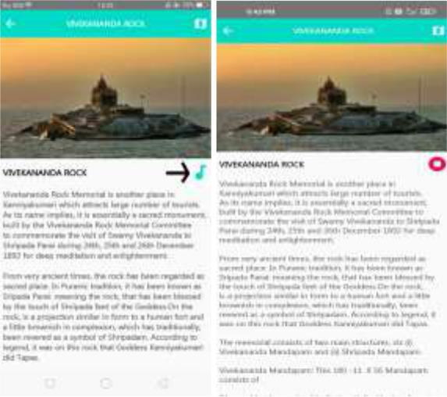
This provides the map wherein the user can locate the easiest route to the tourist spot. Besides this is an user friendly application which requires no login and easy use of the application
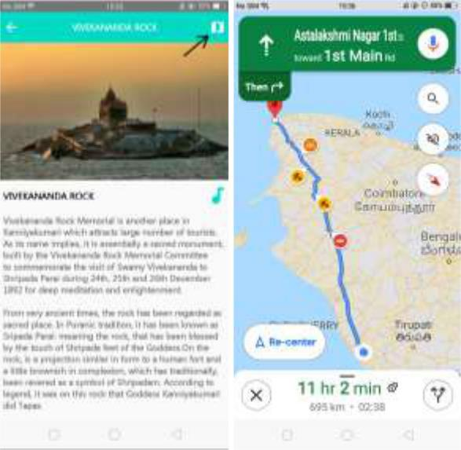

MODULE 4. CHATBOT

Chat bot are there to clear the users doubt regarding the places. For example to look for the nearby hotel, the user can chat with the chatBot to know the details. Thus providing the entire detail regarding the spot including the surrounding details.

There are three process in chatbot:

- Data Collection
- Data Preprocessing

- Output Processing

4.1. DATA COLLECTION

Initially the list of tourist spots in India is collected. Then the information regarding every tourist spots is fed to the system in order to provide the information to the user. With the data provided, the chat bot is trained in order to resolve user related queries.

IJESC, April 2021 27975 http:// ijesc.org/

4.2. DATA PREPROCESSING

Decision tree learning is one of the predictive modeling approaches used in statistics, data mining and machine learning.

It uses a decision tree to go from observations about an item to conclusions about the item's target value.

NATURAL LANGUAGE PROCESSING

Step 1: Sentence Segmentation.
Step 2: Word Tokenization.
Step 3: Predicting Parts of Speech for Each Token.
Step 4: Text Lemmatization.
Step 5: Identifying Stop Words.
Step 6: Dependency Parsing.

Step 7: Finding Noun Phrases.
Step 8: Named Entity Recognition (NER)

CODING THE NLP PIPELINE IN PYTHON
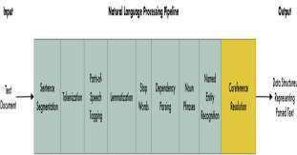

MODULE 4. 3. OUTPUT PROCESSING

In this module the data collected regarding the tourist spots are displayed as output to the user In case of queries, the user can chat with the chatBot, which is built to resolve user related queries where the chatBot is trained to give text as well as audio output to the user.
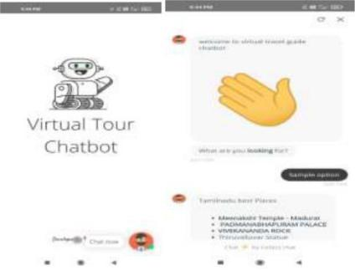

SYSTEM ARCHITECTURE
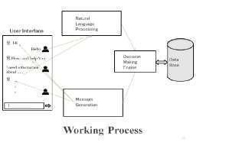

Let’s say you want to get data about something and you decide to use the help of a chatbot. You type in your request. When you

send a message to the chatbot, asking to details of something, the chatbot sends the plain text to the NLP engine. The NLP engine, which uses natural language processing and

NLU(Natural Language Understanding), converts the text message into structured data for itself. This is where the different NLP(Natural Language Processing) models come into play for extracting the intents and entities of the message.

The chatbot moves the data that was collected (the intents and entities) to the decision-making engine.

The decision-making model derives a solid decision based on previous actions and results taken. (It makes a call to the database to make a decision.)

This is where the chatbot converts the decision data to text. Natural language generation (NLG) consists of converting data into plain text. Using NLG, the message generator outputs the message. This message is presented to the user in the form of a text message or voice.

This is where the chatbot converts the decision data to text. Natural language generation (NLG) consists of converting data into plain text. Using NLG, the message generator outputs the message.

5. CONCLUSION

In conclusion, this software will solve many problems in India relating to management of product and information pertaining to tourism. Tourists will get acquainted with all the tourist sites in India and information pertaining to those sites without physically extracting information from people or having to travel long distances to see what the location has to offer. With the availability of the Internet, users have access to the application; hence they are empowered with current and relevant information pertaining to tourism in India. The application will go a long way in assisting tourists in decision making, and also as a source of revenue to the country. This application will make tourism round the Indian country fun and easy because of easy access to relevant information.

6. REFERENCE

- N.T. Thomas, ``An e-business chatbot usinAIML and LSA,'' in Proc. Int. Conf. Adv. Computing, Commun. Informat. (ICACCI), Sep. 2016,pp. 2740_2742.

[2].V. Subrahmanian, A.Azaria, S.Durst, V. Kagan, A. Galstyan, K. Lerman, L. Zhu, E. Ferrara, A. Flammini, and F. Menczer, ``The DARPA Twitter bot challenge,'' Computer, vol. 49, no. 6, pp. 38_46, Jun. 2016.

[3].G. Inc, The Road to Enterprise AI. Pune, Maharashtra:
RAGE Frameworks, 2017.

- P. Jackson and I. Moulinier, Natural Language Processing for Online Applications: Text Retrieval, Extraction and Categ orization, vol. 5. Amsterdam, The Netherlands: John Benjamins, 2007.

- M. Brambilla, M. Dosmi, and P. Fraternali, ``Model-driven engineering of service orchestrations,'' in Proc. IEEE

IJESC, April 2021 27976 http:// ijesc.org/

Congr. Services, Los Angeles, CA, USA, Jul. 2009, pp.
562_569, doi: 10.1109/SERVICES-I.2009.94.

- G. Daniel, J. Cabot, L. Deruelle, and M. Derras, ``Multi-platform chatbot modeling and deployment with the jarvis framework,'' in Advanced Information Systems Engineering (Lecture Notes in Computer Science), vol. 11483, P. Giorgini and B. Weber, Eds. Rome, Italy: Springer,Jun. 2019, pp. 177_193, doi: 10.1007/978-3-030-21290-2_12.

- J. Masche and N.-T. Le, ``A review of technologies for conversational systems,'' in Proc. 5th ICCSAMA Conf. Springer, 2017, pp. 212_225.

IJESC, April 2021 27977 http:// ijesc.org/

